THE WATCHERS

8 February 2019

Massive flash floods hit Atacama desert, Chile
Posted by TW on February 8, 2019 at 20:34 UTC (2 years ago)
Categories: Editors' picks, Floods, Severe weather
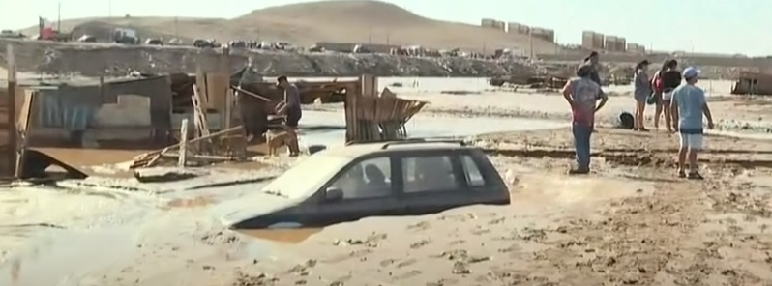
Heavy showers on high altitudes in northern Chile have caused dry river beds to become rushing torrents of water over the past couple of days. Major floods across the desert region of Atacama and continued through February 8.
The flooding has left one dead, one child missing and over 1 200 homeless, officials said but the worst is still not over.

My story
Alan D Horn
Flying into El Loa airport on February 8th 2019 enroute to San Pedro De Atacama we experienced increasing turbulence and the sky blackened even though it was only mid-afternoon. On landing we were met by an anxious driver who hurried us through baggage collection and into his mini bus. Concerned that the journey of 53 miles might have to be abandoned as there was a chance of the road being washed away, he guided the vehicle through flash floods and a lightning storm that had to be experienced to be believed. A pitch-black sky intermittently lit by a frightening display of forked lightening accompanied us for the whole journey.

A phone call to me from our tour operator to say that our hotel had been flooded and evacuated was not what we wanted to hear but an upgrade to the top hotel calmed us. Regardless, the journey time of around 3 hours at an average speed of 14mph illustrates the difficult conditions but hotel, food and excellent Chilean wine made amends.

The following day we were advised to leave as more storms were predicted but nevertheless we stayed as we felt it was a long way to travel and not experience the Atacama Desert – The world's driest place!

The next day –

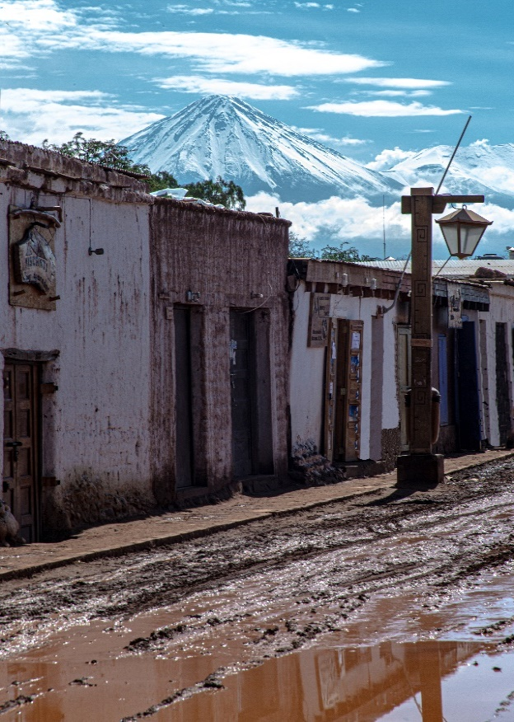

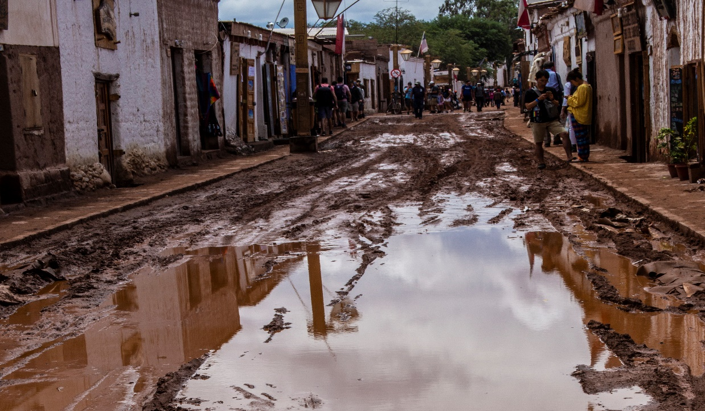

Adobe and rock houses badly damaged

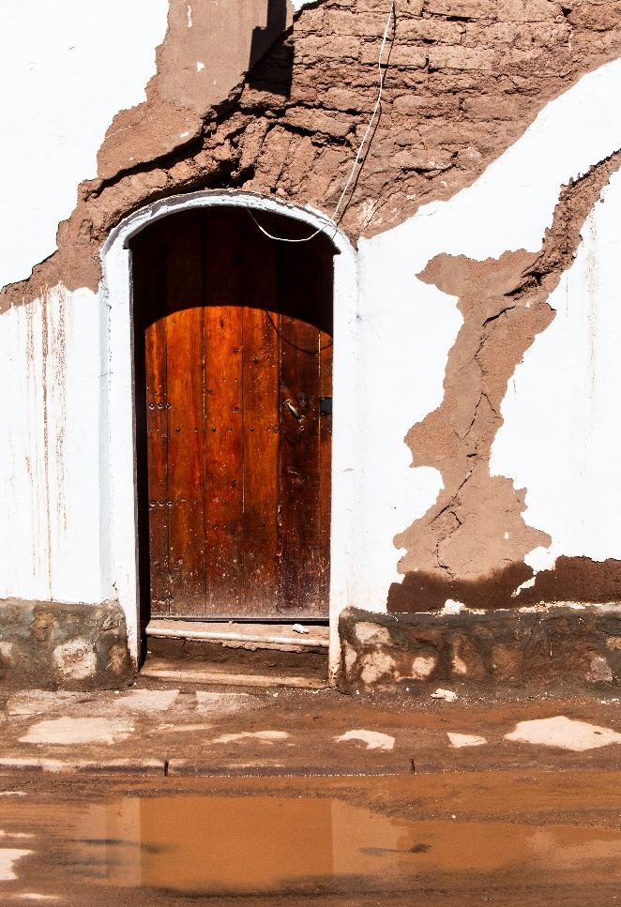

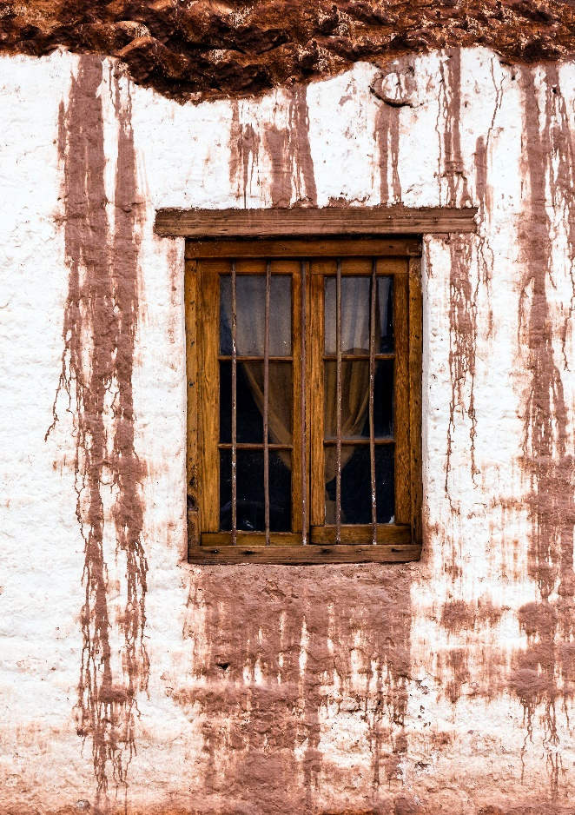

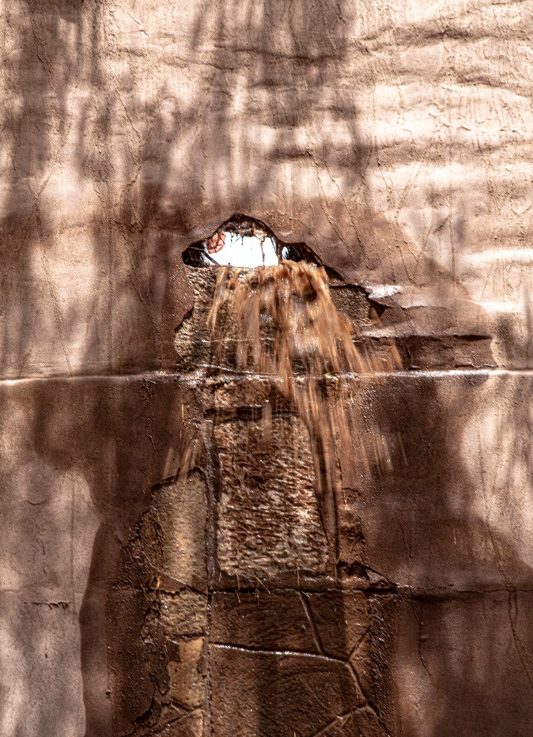

Business carries on

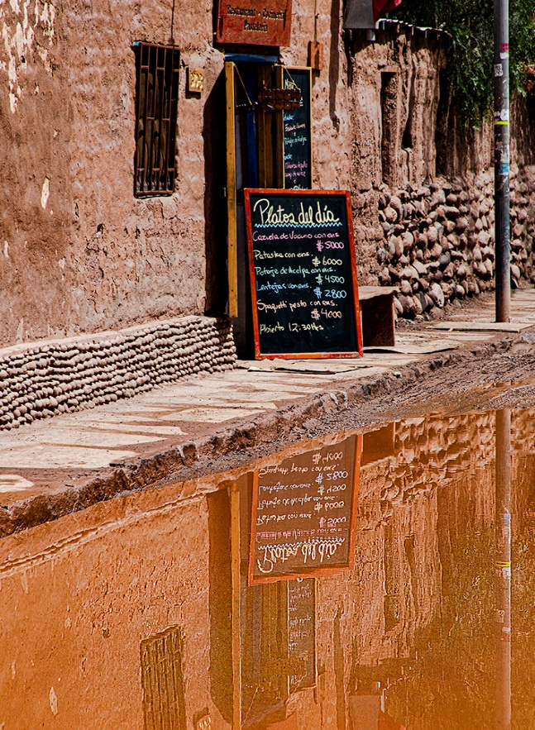

This is the man I met negotiating the pavement area in San Pedro. We made a deal that I would step on to the flooded roadway in exchange for his photo. He is nowhere near as tough as his image suggests but a reasonable deal!

